**Submitted by**

**MANIKANDAN M**

JOB PORTAL MANAGEMENT SYSTEM

TABLE OF CONTENTS

**1 INTRODUCTION**

1.1 PURPOSE ..............................................................................................2

1.2 SCOPE ...................................................................................................2

1.3 OBJECTIVES ..........................................................................................2

**2 FUNCTIONAL REQUIREMENTS**

2.1 PRIMARY ACTORS OF THE SYSTEM ......................................................3

2.2 USE CASE DIAGRAMS

 2.2.1 ADMIN ...........................................................................................4

 2.2.2 JOB PROVIDER ...............................................................................4

 2.2.3 JOB SEEKER ....................................................................................5

2.3 USER STORIES

 2.3.1 ADMIN ...........................................................................................6

 2.3.2 JOB PROVIDER ...............................................................................7

 2.3.3 JOB SEEKER ....................................................................................8

2.4 BUSINESS PROCESS DIAGRAM .............................................................9

**3 NON-FUNCTIONAL REQUIREMENTS**

.................................................................................................................. 10

**4 TECHNICAL REQUIREMENTS**

.................................................................................................................. 12

**5 CONCLUSION**

.................................................................................................................. 12

**1 INTRODUCTION**

**1.1 Purpose**

The purpose of this Software Requirements Specification (SRS) document is to define the requirements for the development of a Job Portal System. This system is designed to act as a bridge between job seekers and employers, allowing users to interact through a unified platform where job opportunities can be posted, discovered, and applied for efficiently.

**1.2 Scope**

The Job Portal System will be a web-based application that facilitates job listings, resume submissions, profile management, and job applications. It will support three main types of users: job seekers, employers, and administrators. The system will provide functionalities such as job search and filters, application tracking, job posting, candidate search, and user account management. The platform aims to improve the hiring process by providing a centralized, automated, and user-friendly environment.

**1.3 Objectives**

The primary objective of the Job Portal System is to provide an efficient and user-friendly platform that connects job seekers with potential employers. The system aims to help job seekers find relevant job opportunities that match their skills, qualifications, and preferences, while enabling employers to post job openings and search for suitable candidates with ease. By automating and streamlining various aspects of the recruitment process, the system reduces the time and effort required for both hiring and job searching. Additionally, the platform ensures the secure handling of user data and promotes smooth, effective interaction between all users of the system.

**2 FUNCTIONAL REQUIREMENTS**

* 1. **Primary actors of the system**
* Job Seeker: The job seeker is the primary user of a job portal system who is actively looking for employment. Their main functions involve creating a detailed profile that includes personal information, educational background, work experience, skills, and a resume. Once registered, the job seeker can browse available job listings, apply filters based on criteria such as location, industry, job type, and salary, and submit applications for suitable positions. Additionally, they can track the status of their applications, receive notifications about new job postings that match their profile, and save or bookmark jobs for future reference. The job portal often allows them to set up alerts and recommendations based on their interests and activity, helping them to stay informed about relevant opportunities.
* Job Provider: The job provider, often a company or recruitment agency, uses the job portal to find and hire qualified candidates. Their functions begin with creating a company profile and posting detailed job listings, which include job descriptions, required qualifications, experience levels, and other relevant details. They can search the database of registered job seekers, filter candidates based on specific criteria, and view their resumes and profiles. Job providers can manage incoming applications, shortlist suitable candidates, and initiate communication for interviews or further steps in the hiring process. The platform also enables them to schedule interviews and track the progress of different job openings, making the recruitment process more organized and efficient.
* Platform Admin: The platform admin is responsible for managing and maintaining the integrity and functionality of the entire job portal system. Their role includes user management tasks such as approving, monitoring, or deactivating both job seeker and job provider accounts. The admin reviews and moderate content to ensure that job postings and user profiles meet the platform’s guidelines and are free of spam or fraudulent information. In addition to overseeing the user experience, the administrator handles technical maintenance, system performance monitoring, and data security. They also generate reports on platform usage, address user complaints or technical issues, and ensure the platform operates smoothly, securely, and in compliance with any applicable regulations or policies.

**2.2 Use case diagrams**

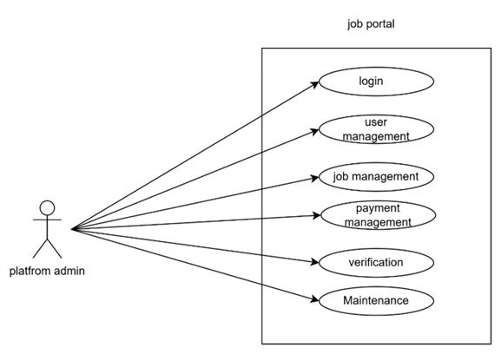 **2.2.1 Admin**

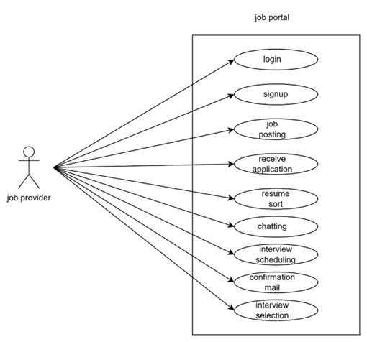**2.2.2 Job provider**

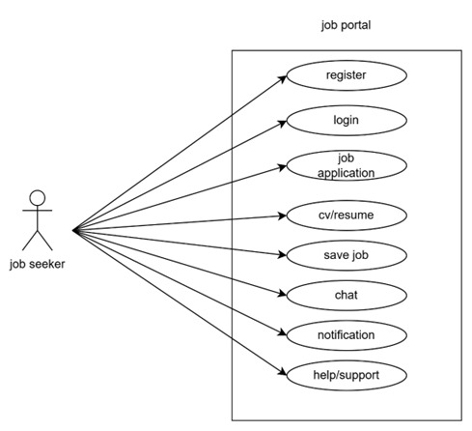**2.2.3 Job seeker**

**2.3 User stories**

|  |  |  |
| --- | --- | --- |
| **AS A [type of user]** | **I NEED TO [do some task]** | **SO THAT I CAN [get some result]** |
| Platform Admin | Login to the portal by entering details | Ensure an authorized access to the platform, different user have different login details |
| Platform Admin | Maintain user accounts and permission | Allows job seekers and employers to create profiles, providing essential details, job seekers and job providers can track application status |
| Platform Admin | Maintain payments and subscription plans | Allows users to unlock premium levels, users can upgrade or cancel subscription, improves the growth |
| Platform Admin | Job management and details | Ensure accurate, up-to-date listings for job seekers, help users to get the job opportunities easily |
| Platform Admin | Perform Regular updates and maintenance | Keep the platform running smoothly without any errors or bugs |

**2.3.1 Admin**

**2.3.2 Job provider**

|  |  |  |
| --- | --- | --- |
| **AS A [type of user]** | **I NEED TO [ do some task]** | **SO THAT I CAN [get some result]** |
| Job provider | Login | Register and job details |
| Job provider | Finding candidates | Searching people who have the right skill and experience |
| Job provider | Posting job advertisements | Sharing with website, newspapers, or social media. |
| Job provider | Receive application | Checking resumes and application to shortlist |
| Job provider | Coordinating interviews | Scheduling meeting with candidates. |
| Job provider | Conformation mail | Helping candidates improve if they don’t get selected or select |

**2.3.3 Job seeker**

|  |  |  |
| --- | --- | --- |
| **AS a (type of user)** | **I need to (do some task)** | **So that I can (get some result)** |
| Job seeker | Login into the application by entering personal details | access the platform to find oppurtunities |
| Job seeker | upload my CV/Resume | Showcase my skills and provide details to the job provider |
| Job seeker | Search and apply for the job | Be eligible in the eyes of the employer in order to obtain the desired position |
| Job seeker | Save jobs | I can apply later or track interesting jobs |
| Job seeker | Message and Get notifications | I can keep contact with the employers |
| Job seeker | Access help/support | I can resolve any issues with the account |

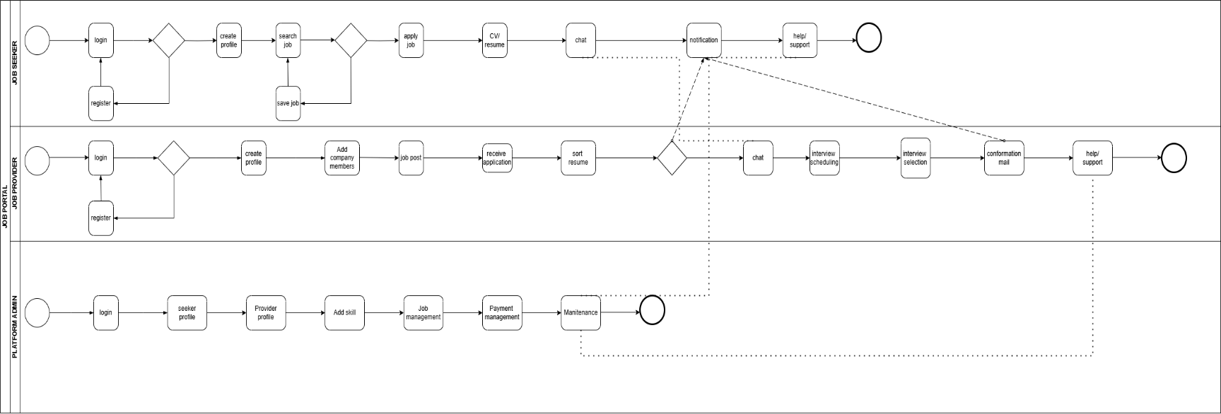**2.4 Business process diagram**

**3 NON-FUNCTIONAL REQUIREMENTS**

**1. Performance Requirements**

* The system should support at least 1000 concurrent users without performance degradation.
* Page load times should not exceed 2 seconds under normal load.
* The system should be capable of handling 100,000 job postings and 500,000 user accounts efficiently**.**

**2. Scalability**

* The system should be designed to allow horizontal scaling to accommodate growing users and data volume.
* Support for cloud deployment to scale resources as needed.

**3. Reliability**

* The system should have 99.9% uptime over a monthly period.
* The system should recover from crashes and continue operation without data loss.

**4. Availability**

* The job portal must be available 24/7 with minimal scheduled maintenance.
* Downtime for upgrades should not exceed 1 hour per month.

**5. Security**

* User passwords must be stored using strong hashing algorithms (e.g., bcrypt).
* All data transmission must be encrypted using HTTPS (SSL/TLS).
* Role-based access control must be enforced (e.g., admin, recruiter, job seeker).
* Must protect against common vulnerabilities like SQL injection, XSS, and CSRF.

**6. Usability**

* The system should have an intuitive and responsive user interface accessible on desktops, tablets, and mobile phones.
* Users should be able to learn the core features within 30 minutes without external help.

**7. Maintainability**

* The codebase should follow consistent coding standards and be well-documented.
* It should be easy to fix bugs and extend functionality with minimal changes.

**8. Portability**

* The system should be deployable on Linux and Windows servers.
* It should support major web browsers like Chrome, Firefox, Safari, and Edge.

**9. Backup and Recovery**

* The system must perform daily backups of the database.
* In the event of a system failure, full recovery should be possible within 2 hours

**4 TECHNICAL REQUIREMENTS**

|  |  |
| --- | --- |
| Processor | Intel Core i5 |
| Hard Disk | 40GB to 80GB |
| Memory | 16GB |
| OS | Windows 11 |
| Front end | HTML, CSS, JavaScript, Bootstrap and Angular |
| Back end | C#, ASP.net core |
| Database | MS SQL |
| IDE | Visual Studio code, visual studio |

**5 CONCLUSION**

The Job Portal System SRS document outlines a comprehensive framework for developing a robust and user-friendly platform that connects job seekers with employers. It details all functional and non-functional requirements necessary to ensure a seamless experience for users, including registration, job posting, job search, application tracking, and communication features. By adhering to the specifications described herein, developers and stakeholders can ensure the system meets user expectations, operates efficiently, and is scalable for future enhancements. The successful implementation of this system will bridge the gap between employers and potential candidates, streamlining the recruitment process for both parties.